# CS 255 System Design Document

Mac Grier

2/20/2025

## UML Diagrams

### UML Use Case Diagram

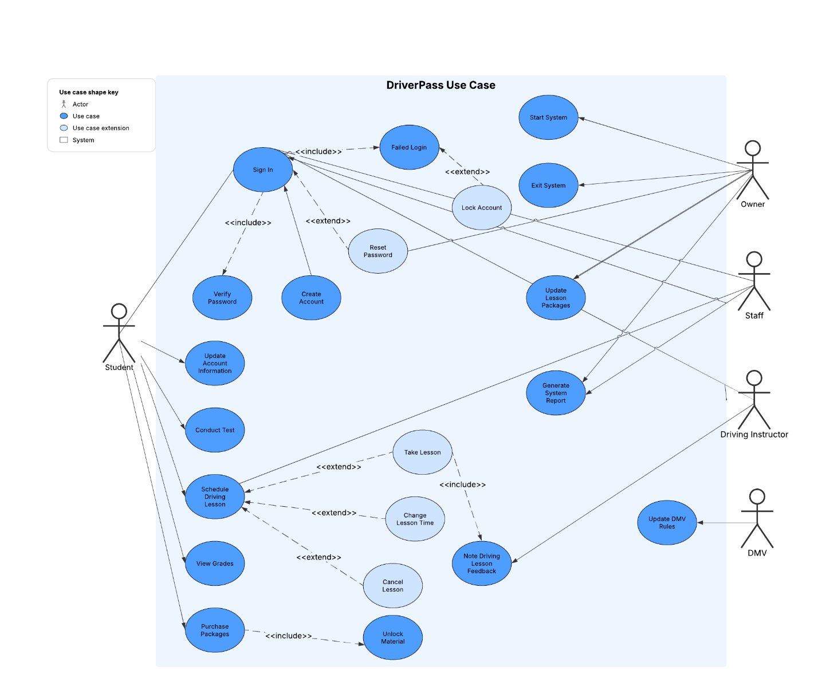

### UML Activity Diagrams

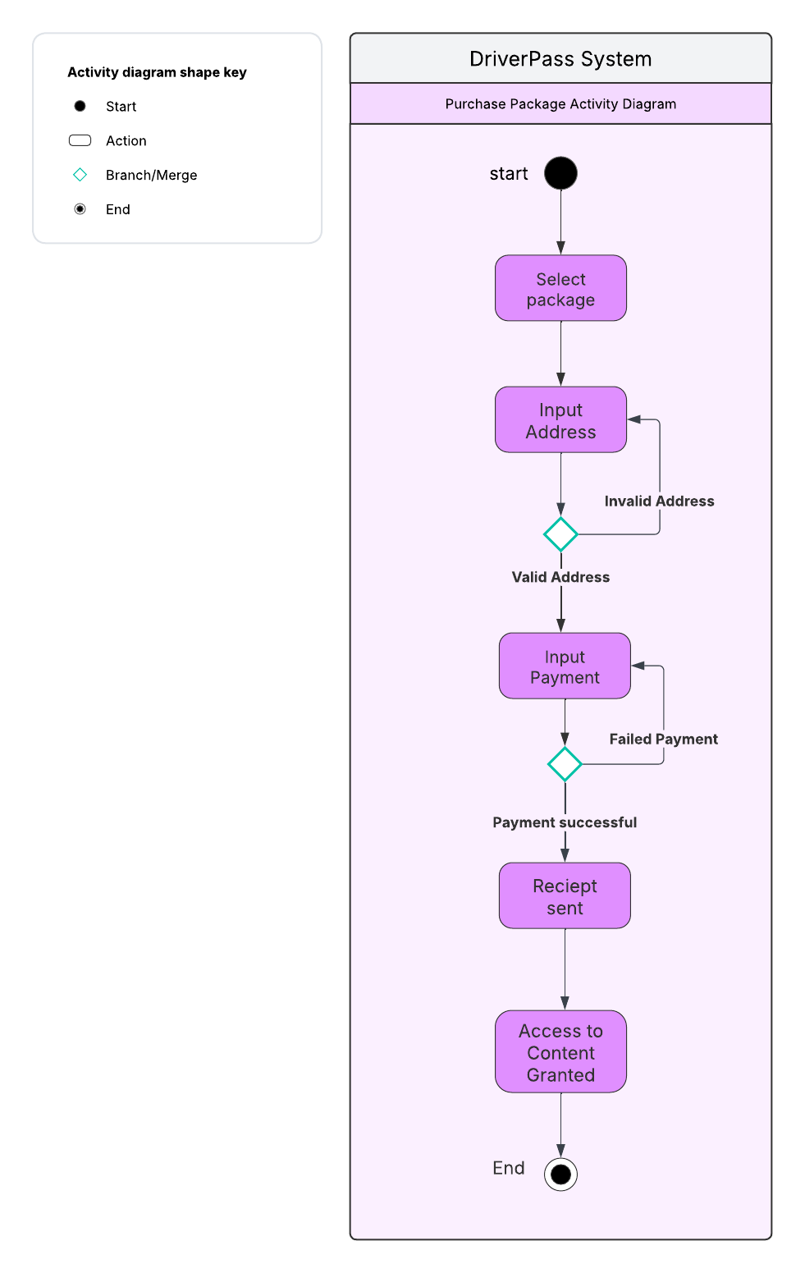

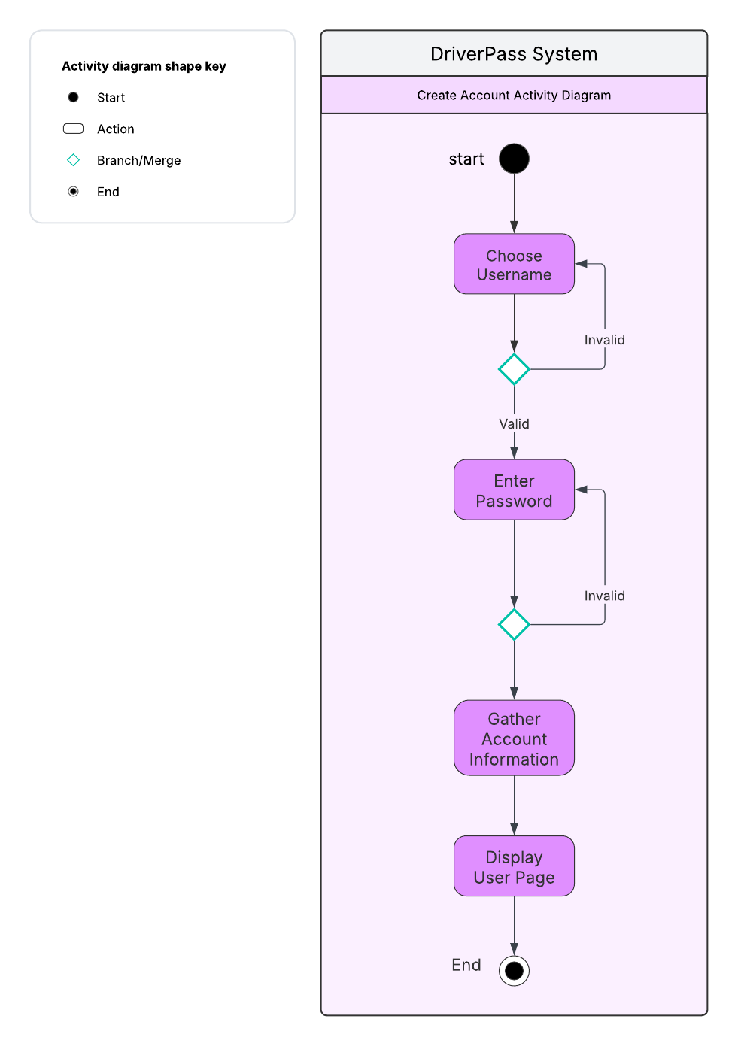

### UML Sequence Diagram

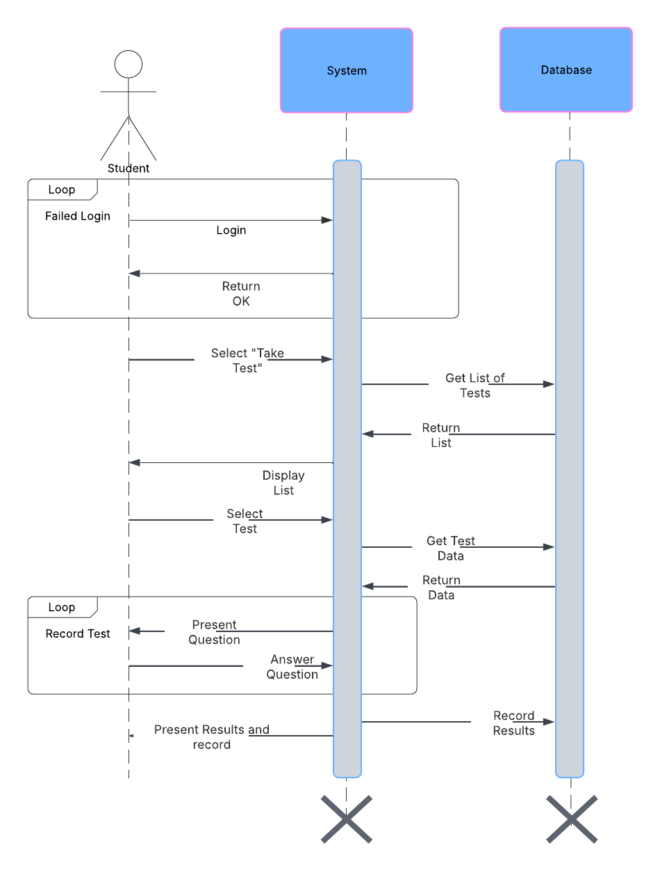

### UML Class Diagram

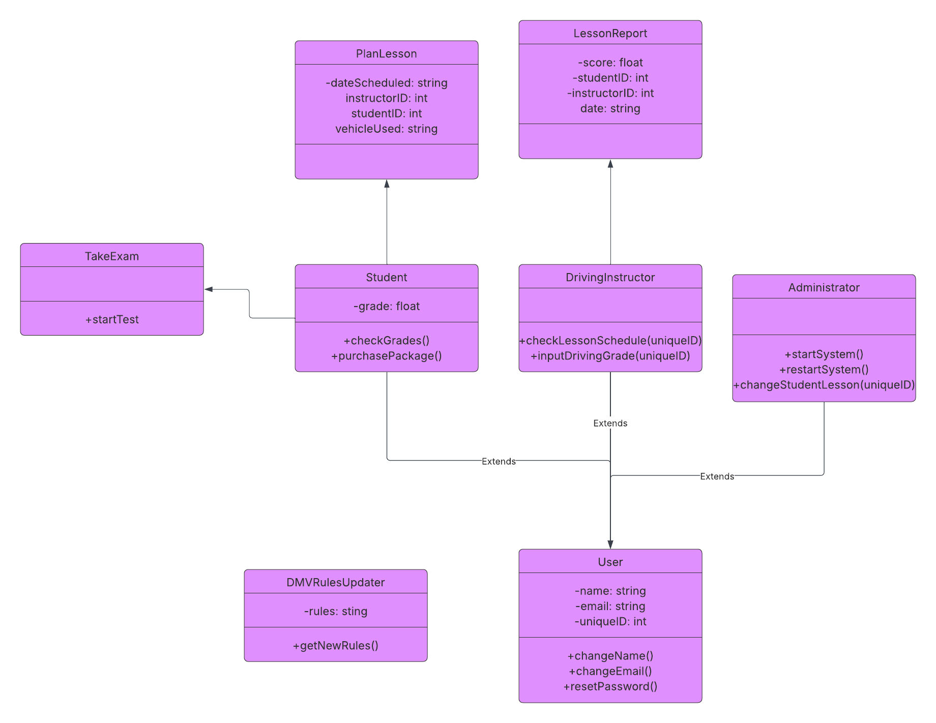

## Technical Requirements

Hardware:

* Servers:
  + Application servers handing the website’s function
  + Database servers using a system like MySQL for user data
* Physical data storage, either SSD or hard drive

Software:

* Database management system like MySQL
* Linux operating system for servers
* Security solutions like OAuth to securely authenticate users

Tools:

* IDE for project development and maintenance
* Modern computers to create and test system on
* Model creation software e.g. Lucidchart

Infrastructure:

* Hi-speed internet
* Cloud hosting
* Hardware and software firewalls
* System backups at regular intervals
* System performance monitoring
* Developmental and public release servers for ongoing development